1 Introduction 3
1.1 References 3
1.2 Overview of IEC 62541 3
1.2.1 General Overview 3
1.2.2 IEC 62541 Services 5
1.2.3 IEC 62541 Historical Access 9
1.2.4 IEC 62541 Meta Model 9
2 IEC 61850 ACSI Mapping Approach 13
2.1 Backward Compatibility 13
2.1.1 Backward Compatibility with Existing IEC 62541 Clients and Servers 13
2.1.2 Backward Compatibility with IEC 61850 Part 8-1 13
2.1.3 Backward Compatibility Existing OPC COM Clients and Servers 13
3 IEC 61850 Object Model Mapping 16
3.1 IEC 61850 Object Types Above Logical Device 16
3.2 IEC 61850 Logical Devices 17
3.3 IEC 61850 Logical Nodes 19
3.4 Data Sets 20
3.5 Report Control Blocks 21
3.5.1 Reports 21
3.6 Log Control Blocks 22
3.7 IEC 61850 Data Objects 22
3.8 IEC 61850 Measurements 25
3.8.1 Nested DataObjects 25
3.9 IEC 61850 Functional Constraints 25
3.10 IEC 61850 Data Attributes 26
3.10.1 IEC 61850 Data Attribute Mapping 27
3.10.2 IEC 61850 Quality type 28
3.10.3 Specific Data Mapping 29
3.10.4 IEC 61850 ServiceError type 30
3.10.5 IEC 61850 TriggerConditions type 30
3.10.6 IEC 61850 ReasonCode (ReasonForInclusion) 30
3.10.7 IEC 61850 Aggregates 30
3.11 IEC 61850 Data Types 30
3.12 IEC 61850 Hierarchy 32
4 IEC 61850 ACSI Mapping 34
4.1 ACSI Service Mapping 34
4.1.1 IEC 61850 Association Multiplicity 34
4.1.2 IEC 61850 Association Session Model 34
4.1.3 IEC 61850 Solicited services 35
4.1.4 IEC 61850 Unsolicited services 35
4.2 IEC 61850 Association 35
4.2.1 Associate 35
4.2.2 Abort 36
4.2.3 Release 36
4.2.4 HeartBeat Messaging 36
4.3 IEC 61850 Server Services 37
4.3.1 GetServerDirectory 37
4.4 IEC 61850 LogicalDevice Services 37
4.4.1 GetLogicalDeviceDirectory 37
4.5 IEC 61850 LogicalNode Services 37
4.5.1 GetLogicalNodeDirectory 37
4.5.2 GetAllDataValues 37
4.6 IEC 61850 Data Access Services 37
4.6.1 GetDataValues 37
4.6.2 SetDataValues 37
4.6.3 GetDataDirectory 37
4.6.4 GetDataDefinition 37
4.7 IEC 61850 DataSet Services 37
4.7.1 GetDataSetValues 37
4.7.2 SetDataSetValues 38
4.7.3 CreateDataSet 38
4.7.4 DeleteDataSet 38
4.7.5 GetDataSetDirectory 38
4.8 IEC 61850 Setting Group Control Block Services 38
4.8.1 SelectActiveSG 38
4.8.2 SelectEditSG 38
4.8.3 SetEditSGValue 38
4.8.4 ConfirmEditSGValues 38
4.8.5 GetEditSGValue 38
4.8.6 GetSGCBValues 38
4.9 IEC 61850 Report Control Block Services 38
4.9.1 Report 38
4.10 IEC 61850 Log Control Block Services 39
4.11 IEC 61850 Control Services 39
4.11.1 Select 39
4.11.2 SelectWithValue 39
4.11.3 Cancel 39
4.11.4 Operate 39
4.11.5 CommandTermination 39
4.11.6 TimeActivatedOperate 39
4.12 IEC 61850 File Transfer Services 39

- Introduction
  - References
- IEC 62541-1, OPC Unified Architecture – Part 1: Overview and Concepts
- IEC 62541-2, OPC Unified Architecture – Part 2: Security model
- IEC 62541-3, OPC Unified Architecture – Part 3: Address space model
- IEC 62541-4, OPC Unified Architecture – Part 4: Services
- IEC 62541-5, OPC Unified Architecture – Part 5: Information model
- IEC 62541-6, OPC Unified Architecture – Part 6: Mappings
- IEC 62541-7, OPC Unified Architecture – Part 7: Profiles
- IEC 62541-8, OPC Unified Architecture – Part 8: Data Access
- IEC 62541-9, OPC Unified Architecture – Part 9: Alarms and conditions
- IEC 62541-10, OPC Unified Architecture – Part 10: Programs
- IEC 62541-11, OPC Unified Architecture – Part 11: Historical access
- IEC 62541-12, OPC Unified Architecture – Part 12: Discovery
- IEC 62541-13, OPC Unified Architecture – Part 13: Aggregates
  - Overview of IEC 62541
    - General Overview
IEC 62541, developed by the OPC Foundation and also known as OPC Unified Architecture (OPC-UA), provides a framework to represent complex information models and a standard set of services to access that information. It also provides a state of the art security model that is an integral part of the specification and incorporates features which ensure reliability and fault tolerance. IEC 62541 is designed to be platform impendent and also development language independent. Implementations, toolkits and SDKs are available on a large number of platforms and for Ansi “C’, C++, C#/.Net and Java development
IEC 62541 is a generic specification that can represent any existing information model (e.g. IEC 61850/61400-25) and make the information and events accessible to generic applications via a limited set of services.
The value of IEC 62541 is its ability to integrate data and events from a variety of sources into in single framework and provide this data at any level in the system. For example, IEC 62541 supports non-hierarchical data models such as the IEC Common Information Model. This data will typically include data coming from IEDs, gateways or distributed Energy Resource devices but can also incorporate data coming from a power plant Distributed Control System (DCS) or SCADA system or a cloud based data source. IEC 62541 Servers can be applied to small embedded devices, EMS or DMS, up to Enterprise Resource Planning (ERP) systems and at level in between.
IEC 62541 is a multipart specification including:
- Part 1: Overview and Concepts – A short white-paper like overview of UA.
- Part 2: Security Model – A non-normative introduction to threats and countermeasures.
- Part 3: Address Space Model - Defines a service independent AddressSpace Model in which IEC 61850 type and instance data can be represented as well as the References between them. The Address Space Model provides building block constructs for data modelers: Nodes, Objects, Variables, Events, etc.
- Part 4: Services - Defines a data independent set of Services for accessing the AddressSpace exposed by an IEC 62541 compliant Server.
- Part 5: Information Model – Specifies general purpose objects (e.g. Diagnostic Object, Audit Events).
- Part 6: Mappings - Defines “technology mappings” which describe how IEC 62541 can be implemented over different underlying technologies.
- Part 7: Profiles – Defines conformity groups for implementation and certification.
- Part 8: Data Access – Is a generic information model that adds constructs for telemetry data exchange (e.g. Engineering Units and specific data types).
- Part 9: Alarms and Conditions – Is a generic information model that adds stateful Alarms and Conditions.
- Part 10: Programs – Is a generic information model that adds long running executable entities with state machines.
- Part 11: Historical Access – Is a generic information model that adds time series data and time series Events constructs
- Part 12: Discovery – Describes an infrastructure that supports finding servers in a network and obtaining and managing the information required to connect to a server
- Part 13: Aggregates – An information model that describe calculations that aggregate data (Average, Minimum, Maximum, StandardDeviation, TimeInState). These calculations can be applied to realtime data as well as Historical (time series) data..
The diagram below illustrates the conceptual partitioning of the IEC 62541 specifications.
Figure 1: IEC 62541 Layers
IEC 62541 Services can be implemented over a variety of underlying protocols such as TCP, AMQP HTTP or HTTPS. It makes uses binary of XML encoding of data and of appropriate security technology to ensure that the data on the wire is secure. This functionality is provided by stacks which are provided by the OPC Foundation. A number of vendors provide SDK’s, toolkit or other API from which application can be developed.
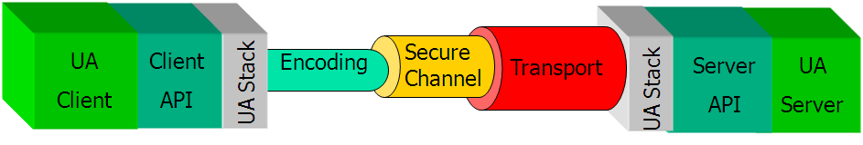
Figure 2: IEC 62541 Protocol Modularity
IEC 62541 also address the following key functionality:
- Performance – IEC 62541 defines Services for efficient exchange of repetitive measurements and reports.
- Reliability –. IEC 62541 includes application level protocols to insure that no data is lost. They also provide fast detection of communication problems and recovery without interruption or requiring any reconfiguration of data streams.
- Availability –IEC 62541 application level redundancy features and functionality include defining how redundant Clients and Servers interoperate with regard to application failover. This allows systems that are composed of Clients and Servers from different vendors to still supply high availability. IEC 62541 high availability features are complementary to technologies such as HSR and PRP.
- Scalability – IEC 62541 has been implemented in small embedded controllers and used as an interface to a large system. To support the embedded devices, IEC 62541’s messaging scheme has been designed so that Client and Server can negotiate communication parameters. In this way, a Client can discover at run-time the capabilities of a resource constrained device. At the high end, IEC 62541 includes the capability to implement load balancing and Server federation to enable simultaneous communication with a vast number of devices. The key is that Clients can easily discover the functionality supported by a Server.
- Security –. IEC 62541 includes multiple levels of security. It provides secure data on the wire by providing encryption and signing. It can restrict Server access to approve Client applications. In accordance with IEC 62351, IEC 62541 provides fine grain access control to individual instance and properties on a per user role basis. It provides auditing capabilities to ensure traceability. All of these feature can be configured at a site allow the ultimate selection of the required security to be determined by a site.
- Predefined State Models – IEC 62541 has a large number of existing information models that provide standard information.
- Model Enabled Data Access –IEC 62541 supports Browsing type and instance data at run-time via a generic set of standard Services. This includes describing the structure of the data by browsing, read and writing simple and complex data values or subscribing to changes of data.
    - IEC 62541 Services
      - Overview
IEC 62541 Services are divided into Service Sets, each defining a logical grouping of Services used to access a particular aspect of the Server. The Service Sets are described below. The Service Sets and their Services are specified in IEC 62541 Part 4: Services. Whether or not a Server supports a Service Set, or a specific Service within a Service Set, is defined by its Profiles. Profiles are described in IEC 62541 Part 7 Profiles.
      - Discovery Service Set
This Service Set defines Services used to discover IEC 62541 Servers that are available in a system. It also provides a manner in which clients can read the security configuration required for connection to the Server. The Discovery Services are implemented by individual Servers and by dedicated Discovery Servers. Well known dedicated Discovery Servers provide a way for clients to discover all registered IEC 62541 Servers. IEC 62541 Part 12: Discovery describes additional features that dedicated Discovery Servers can provide.
      - SecureChannel Service Set
This Service Set defines Services used to open a communication channel that ensures the confidentiality and integrity of all Messages exchanged with the Server. A summary of all aspects of security along with basic concepts for security are discussed in IEC 62541 Part 2 Security Model.
The SecureChannel Services are unlike other Services because they are typically not implemented by the IEC 62541 application directly. Instead, they are provided by the communication stack that the IEC 62541 application is built on. A SecureChannel is a long-running logical connection between a single Client and a single Server. This channel maintains a set of keys that are known only to the Client and Server and that are used to authenticate and encrypt Messages sent across the network. The SecureChannel Services allow the Client and Server to securely negotiate the keys to use.
The exact algorithms used to authenticate and encrypt Messages are described in the security policies for a Server. These policies are part of the profiles a server and client exposes. The client can also discover the security policies a server exposes via the Discovery Service Set. A Client selects the appropriate endpoint that supports the desired security policy by the Server when it creates a SecureChannel.
When a Client and Server are communicating via a SecureChannel they verify that all incoming Messages have been signed and/or encrypted according to the security policy. An IEC 62541 application is expected to ignore any Message that does not conform to the security policy for the channel.
A SecureChannel is separate from the IEC 62541 Application Session; however, a single IEC 62541 Application Session may only be accessed via a single SecureChannel. This implies that the IEC 62541 application is able to determine what SecureChannel is associated with each Message. A communication stack that provides a SecureChannel mechanism but that does not allow the application to know what SecureChannel was used for a given Message cannot be used to implement the SecureChannel Service Set.
The relationship between the IEC 62541 Application Session and the SecureChannel is illustrated in the diagram below.. The IEC 62541 applications use the communication stack to exchange Messages. First, the SecureChannel Services are used to establish a SecureChannel between the two communication stacks, allowing them to exchange Messages in a secure way. Second, the IEC 62541 applications use the Session Service Set to establish an IEC 62541 application Session.
Figure 3: SecureChannel and Session Services
      - Session Service Set
This Service Set defines Services used to establish an application-layer connection in the context of a Session on behalf of a specific user. They include the ability to define the Locale of the client. The client application can also change the user that is associated with a given session. The session is maintained even if the secure channel is interrupted, allowing for fast recoveries from short communication errors.
      - Subscription Service Set
The Subscription Service Set is used by the Client to create and maintain Subscriptions. IEC 62541 Subscriptions can be seen as dynamic as opposed to an IEC 61850 Report Control Block which defines Subscription configuration. Subscriptions are entities that periodically publish NotificationMessages for the MonitoredItem assigned to them. The NotificationMessage contains a common header followed by a series of Notifications. The format of Notifications is specific to the type of item being monitored (i.e. Properties, DataVariables, Attributes, and EventNotifiers).
Once created, a Subscription can be shared by multiple Clients. Since backup Clients can monitor an active Client’s Session with the Server, if the active Client ceases to be active, a Server can send data updates to backup Client without data loss.
To protect against non-use by Clients, Subscriptions have a configured lifetime that Clients periodically renew. If any Client fails to renew the lifetime, the lifetime expires and the Subscription is closed by the Server. Expiration of a Subscription does not impact the persistence of IEC 61850 Report Control Block objects in the IEC 62541 Server. It only means that the Server does not try to continue to send data to the Client until the Session is re-established.
IEC 62541 MonitoredItems can be seen as dynamic as opposed to an IEC 61850 DataSet which defines MonitoredItem configuration. When a Subscription is closed, all MonitoredItems assigned to the Subscription are removed. Removal of the MonitoredItems does not impact the persistence of IEC 61850 Data Set objects in the IEC 62541 Server. It only means that the Server no longer need to process data changes from an underlying device for Clients that have failed.
Subscriptions include features that support detection and recovery of lost Messages. Each NotificationMessage contains a sequence number that allows Clients to detect missed Messages. When there are no Notifications to send within the keep-alive time interval, the Server sends a keep-alive Message that contains the sequence number of the next NotificationMessage sent. If a Client fails to receive a Message after the keep-alive interval has expired, or if it determines that it has missed a Message, it can request the Server to resend one or more Messages.
      - NodeManagement Service Set
The NodeManagement Service Set allows Clients to add, modify, and delete Nodes in the AddressSpace. These Services provide an interface for the configuration of a Server’s AddressSpace.
      - View Service Set
Views are publicly defined, Server-created subsets of the AddressSpace. The entire AddressSpace is the default View, and therefore, the View Services are capable of operating on the entire AddressSpace. Future versions of this specification may also define Services to create Client defined Views.
The View Service Set allows Clients to discover Nodes in a View by browsing. Browsing allows Clients to navigate up and down the hierarchy, or to follow References between Nodes contained in the View. In this manner, browsing also allows Clients to discover the structure of the View.
The View Service Set allows browsing both the type system and the instance address space. This allows a Client to discover the structures associated with a given instance.
      - Query Service Set
The Query Service Set allows users to access the address space without browsing and without knowledge of the logical schema used for internal storage of the data.
Querying allows Clients to select a subset of the Nodes in a View based on some Client-provided filter criteria. The Nodes selected from the View by the query statement are called a result set.
Servers may find it difficult to process queries that require access to runtime data, such as device data, that involves resource intensive operations or significant delays. In these cases, the Server may find it necessary to reject the query.
The Query Service Set is optionally used instead of the View Service Set when enhance data filtering is needed.
      - Attribute Service Set
The Attribute Service Set is used to read and write Attribute values. Attributes are primitive characteristics of Nodes that are defined by IEC 62541. They may not be defined by Clients or Servers. Attributes are the only elements in the AddressSpace permitted to have data values. A special Attribute, the Value Attribute is used to define the value of Properties and DataVariables.
Attribute Services Set also includes read and write access to historical data. The Server include properties that define if the node include historical data or if the data is writeable, this includes if the data is accessible by the particular user associated with the session.
      - Method Service Set
Methods represent the function calls of Objects. Methods are invoked and return after completion, whether successful or unsuccessful. Execution times for Methods may vary, depending on the function they are performing.
The Method Service Set defines the means to invoke Methods. A Method is always a component of an Object. Discovery is provided through the browse and query Services. Clients discover the Methods supported by a Server by browsing for the owning Objects that identify their supported Methods.
Because Methods may control some aspect of device operations, method invocation may depend on environmental or other conditions. This may be especially true when attempting to re-invoke a Method immediately after it has completed execution. Conditions that are required to invoke the Method may not yet have returned to the state that permits the Method to start again. In addition, some Methods may be capable of supporting concurrent invocations, while others may have a single invocation executing at a given time.
IEC 62541 defines a number of Methods. These Methods include File Transfer methods, Alarm Acknowledge methods and Alarm Management methods to mention a few..
      - MonitoredItem Service Set
The MonitoredItem Service Set is used by the Client to create and maintain MonitoredItems. MonitoredItems monitor Properties and DataVariables, Attributes and EventNotifiers. They generate Notifications when they detect certain conditions. They monitor Properties and DataVariables for a change in value or status; Attributes for a change in value; and EventNotifiers for newly generated Alarm or Event reports.
Figure 4: IEC 62541 Monitoring Model
Each MonitoredItem identifies the item to monitor and the Subscription to use to periodically publish Notifications to the Client. Each MonitoredItem also specifies the rate at which the item is to be monitored (sampled) and, for Properties and DataVariables and EventNotifiers, the filter criteria used to determine when a Notification is to be generated. Filter criteria for Attributes are specified by their Attribute definitions in IEC 62541 Part 3 Address Space Model.
The sample rate defined for a MonitoredItem may be faster than the publishing rate of the Subscription. For this reason, the MonitoredItem may be configured to either queue all Notifications or to queue only the latest Notification for transfer by the Subscription. In this latter case, the queue size is one.
MonitoredItem Services also define a monitoring mode. The monitoring mode is configured to disable sampling and reporting, to enable sampling only, or to enable both sampling and reporting. When sampling is enabled, the Server samples the item. In addition, each sample is evaluated to determine if a Notification should be generated. If so, the Notification is queued. If reporting is enabled, the queue is made available to the Subscription for transfer.
    - IEC 62541 Historical Access
The IEC 62541 Part 11: Historical Access specification defines of the handling of historical time series data and historical Event data. Included is the specification of the representation of historical data and Events in the IEC 62541 AddressSpace. This specification provide additional details on the Historical attribute service (see Clause 1.2.2.9)
An IEC 62541 Server supporting Historical Access provides one or more IEC 62541 Clients with transparent access to different historical data and/or historical Event sources. The historical data or Events may be located in a proprietary data collection, database or a short term buffer within memory. An IEC 62541 Server supporting Historical Access may or may not provide historical data and Events for some or all available Variables, Objects, Properties or Views within the server AddressSpace. As with the other Information Models, the AddressSpace of an IEC 62541 Server supporting Historical Access is accessed via the Browse or Query Service sets. An IEC 62541 Server supporting Historical Access provides a way to access or communicate to a set of historical data and/or historical Event sources. The types of sources available are a function of the Server implementation.
    - IEC 62541 Meta Model
      - Overview
The diagram below illustrates the generic IEC 62541 meta model including Types and Instances of Objects and References. The meta-model also include a means to describe simple and Complex Data Types.
Figure 5: IEC 62541 Meta Model
      - The IEC 62541 Object Model
The primary objective of the IEC 62541 Address Space is to provide a standard way for Servers to represent objects to clients. The IEC 62541 Meta Model has been designed to meet this objective. It defines Objects in terms of Variables and Methods. It also allows References to other Objects to be expressed.
In addition Objects can by typed, i.e. IEC 62541 provides a way to define and expose Object Types (classes with member variables and member methods) and Object Instances.
IEC 62541 does not require that a Server exposes a complete Type Model for all Instances that it exposes. A simple Address Space model like in classic OPC Data Access can be built using Folder Objects and Variables. But the availability of a Type Model by a Server makes the semantics of a system much easier to discover.
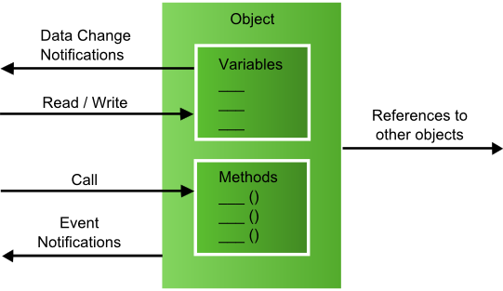
Figure 6: IEC 62541 Object
The IEC 62541 Services are used to access the Objects and their components like Reading or Writing a Variable Value, Calling a Method or receiving Events from the Object. The Browse Service can be used to explore References between Objects, Variable and their components.
The elements of this model are represented in the Address Space as Nodes. Each Node is assigned to a Node Class e.g. Object, Variable and Method each represents a different element of the IEC 62541 Meta Model.
      - Node Model
The set of Objects and related information that the IEC 62541 Server makes available to Clients is its Address Space.
Objects and their components are represented in the Address Space as a set of Nodes described by Attributes and interconnected by References.
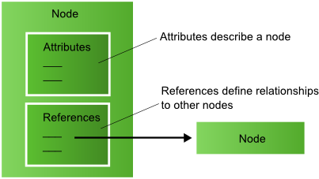
Figure 7: IEC 62541 Node
Node Classes define Attributes and References for different Nodes. IEC 62541 defines eight Node Classes. Each Node in the Address Space is a realization of one of these Node Classes. IEC 62541 Clients and Servers are not allowed to define additional Node Classes or extend the definitions of these Node Classes (e.g. the list of Attributes for a Node Class).
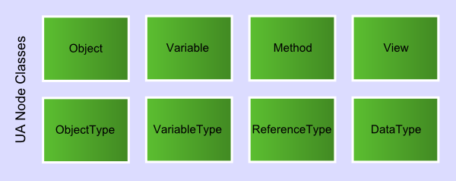
Figure 8: IEC 62541 Node Classes
Attributes are data elements that describe Nodes. Clients can access Attribute values using Read, Write, Query, and Subscription/MonitoredItem Services.
Attributes are elementary components of Node Classes. Attribute definitions are part of the Node Class definitions and are therefore known to Clients.
Each Attribute definition consists of an Attribute id, a Name, a Description, a Data Type and a Mandatory/Optional indicator. The set of Attributes defined for each Node Class cannot be extended by Clients or Servers. When a Node is created in the Address Space, the values of the Mandatory Node Class Attributes must be provided.
References are used to relate Nodes to each other. They can be accessed using the Browse and Query Services.
Like Attributes, they are defined as fundamental components of Nodes. Unlike Attributes, References are defined as Instances of ReferenceType Nodes. ReferenceType Nodes are visible in the Address Space and are defined using the ReferenceType Node Class.
The Node that contains the Reference is referred to as the Source Node and the Node that is Referenced is referred to as the Target Node. The combination of the Source Node, the ReferenceType and the Target Node are used in IEC 62541 services to uniquely identify References. Thus, each Node can Reference another Node with the same ReferenceType only once.
The Target Node of a Reference may be in the same Address Space or in the Address Space of another IEC 62541 Server. Target Nodes located in other Servers are identified in IEC 62541 Services using a combination of the Remote Server Name and the Node ID assigned to the Node by the Remote Server. For example, when scaling up the aggregation of servers, it may not be desirable for all data to be supplied by a single aggregating server. The network address of an endpoint cannot be abstract. However, with off-Server References, the inconvenience of a client having to know specific endpoint addresses is minimized. IEC 62541’s support for partitioning an address space means IEC 62541 can scale to extremely large address spaces and many hundreds of clients without requiring a stateless server.
      - Properties
There are two types of Variables: Properties and DataVariables. The key difference between a Property and a DataVariable is that a Property is a leaf and cannot have other children under it, while a DataVariable can be composed of other DataVariable and Properties. Properties differ from Attributes in that they can be defined and added by the Server and characterise what the Node represents, such as a Breaker or a Governor.
Attributes provide IEC 62541 metadata that is available for all Nodes. Attributes are common to all Nodes of a Node Class and are only defined by the IEC 62541 specification whereas Properties can be Server-defined.
For example, the Data Type Attribute defines the Data Type of Variables whereas a Property can be used to specify the real world characteristic of an Object, Data Variable and other Node.
To prevent recursion, Properties are not allowed to have Properties defined for them. To easily identify Properties, the Browse Name of a Property must be unique in the context of the Node containing the Properties.
A Node and its Properties must always reside in the same Server.
      - Data Variables
An Object Node cannot contain a Value Attribute whereas a Variable Node can. An Object is a container for Variables, Properties or other Objects. For example, a File Object uses a Data Variable to represent the file content as array of bytes. Properties may be used to expose the creation time and owner of the File Object.
- IEC 61850 ACSI Mapping Approach
This document provides a mapping for all aspects of the IEC 61850/61400-25 specification. This includes describing:

- How the services that are specified in IEC 61850 ACSI are mapped to IEC 62541 services and technologies
- How the information model that is represented by IEC 61850/61400-25 is mapped to the information modelling ability of IEC 62541
  - Backward Compatibility
In order to facilitate adoption of IEC 61850 Part 8-2, backward compatibility with existing technology should be considered. One way to do this is for IEC 61850 8-2 to adopt a backward compatible mechanism for how IEC 61850 data and behavior is exposed. This does not mean that additional features solely provided by IEC 62541 cannot be used, only that features that are common be used in a similar way. Servers may expose a subset of IEC 62541 functionality or all functionality. The basic subset only includes the functionality supported by legacy technology and the full superset includes the unique capabilities of IEC 62514. Consequently, IEC 62541 clients may need to discover server capabilities, but can be simultaneously be backward compatible and support the advanced features only provided by IEC 62541.
    - Backward Compatibility with Existing IEC 62541 Clients and Servers
The approached described in this document provides backward compatibility with existing IEC 62541 Clients and Servers. Consequently hundreds of existing IEC 62541applications such as SCADA clients, servers, gateways, historians, and data analysis tools can be used without change.
    - Backward Compatibility with IEC 61850 Part 8-1
The ACSI service model is abstract. If a new mapping takes advantage of that abstractness to completely redo and change the way data is represented and services are implemented compared to what we know today as IEC 61850 8-1, then it would be difficult to add support for IEC 61850 8-2 to existing devices. Instead of helping adoption of IEC 61850 it will set it back substantially. While strict MMS compatibility (bytes on the wire) is not required, support for both stacks in a single device is facilitated if the objects and services that an IEC 61850 8-1 user encounters be reused as much as possible.
    - Backward Compatibility Existing OPC COM Clients and Servers
The OPC Foundation has developed two families of specifications:
- OPC COM – first released in 1991
- OPC Unified Architecture (OPC UA) – first released in 2006
While OPC COM was never standardized in the IEC, OPC UA has been standardized in IEC TC 65 as IEC 62541. The focus of the newer UA specifications has been to address short comings of the legacy OPC COM specifications and to provide additional functionality. The OPC COM specifications, from which IEC 62541 evolved, were:
- OPC Data Access (OPC DA): Read/write and publish/subscribe to current measurement data
- OPC Historical Data Access (OPC HDA): Read and write historical measurement data
- OPC Alarms and Events (OPC A&E): Publish/subscribe generic events as well as alarms that can be acknowledged.
OPC DA has become the de facto standard API in the market for IEC 61850 clients on the Windows platform. Backward compatibility with OPC DA API means that existing IEC 61850 clients and servers that can interface to an IEC 61850 8-1 stack using an OPC DA API will continue to work even if an IEC 61850 8-2 stack is used instead of an IEC 61850 8-1 stack. Many utility operations related products such as SCADA systems from ABB, Siemens, GE, and Areva support the OPC DA API. The diagram for Siemens Spectrum is typical:
Figure 10: Siemens Spectrum SCADA Interfaces Architecture
In the example above, Siemens Spectrum can support IEC 61850 8-2 without any additional development. All of the OPC COM specifications support exposing a hierarchal IEC 61850 based AddressSpace as exemplified in the figure below.
Backward compatibility with OPC COM largely prescribes how ACSI is exposed via IEC 62541. Of course this approach may not take full advantage of IEC 62541 functionality that goes beyond IEC 61850 8-1 or OPC COM functionality. One way to take advantage of advance IEC 62541 features is to allow clients and servers to support either a “Base” or a “Full” IEC 61850 8-2 “Data Profile”. A Base Data Profile would only require a server to expose and a client to consume an OPC DA COM backward compatible IEC 62541 Address Space that does not employ the unique features of IEC 62541. A Full Data Profile would require a server to expose both a backward compatible IEC 62541 Address Space and also one that exposed unique IEC 62541 features. Issues to address by the definition of these profiles include:
- While OPC DA COM Clients and Servers have limited support for exchanging complex data, IEC 62541 has full support (such as being able to retrieve a Logical Device as a single complex object instead of a set of nested objects). The advantage of using complex data is that the data related to an entire IEC 61850 complex data type can be read or written to using a single read or write call instead of collection of Browse and read/write calls. The Basic Data Profile Address Space shall expose all IEC 61850 data as a hierarchy of simple data types and is not required to expose complex data. The Full Data Profile Address Space shall include both the hierarchy of simple data types and also complex data types representing complex IEC 61850 data. Thus, the IEC 61850 8-2 Basic Data Profile compliant Clients and Servers shall support exchange of all data using only simple data types. IEC 61850 8-2 Full Data Profile compliant Clients and Servers shall support exchange of reading and writing of complex IEC 61850 data using a single complex data type.

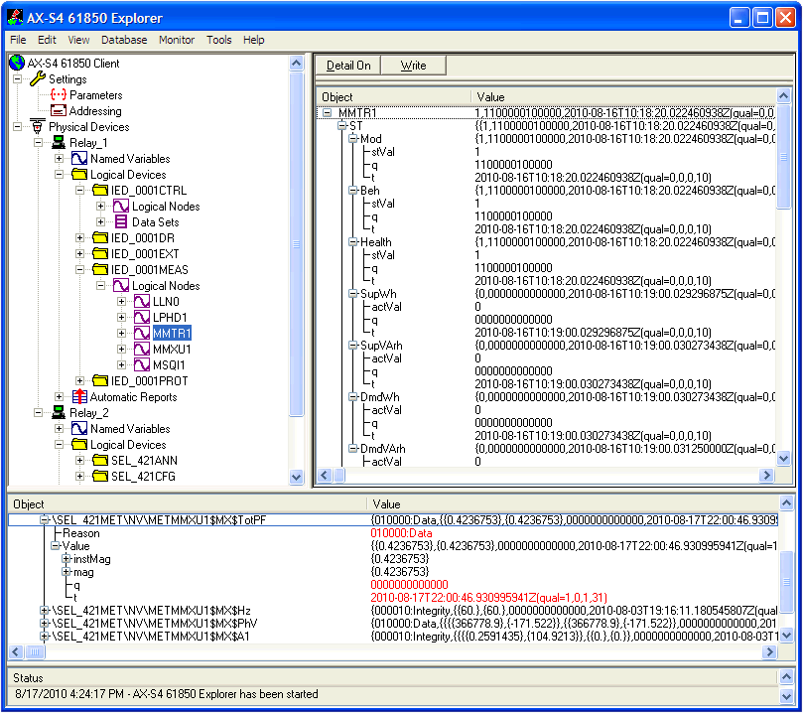
Figure 11: Example IEC 61850 Data Exposed in an OPC DA Address Space

- While OPC DA COM Clients and Servers cannot support transactions, IEC 62541 can (such as the grouping of reads and writes required for SBO). The advantage of using transactions is that a server can more reliably and quickly detect and recover from communication failures if a collection of reads or writes are grouped within a single atomic transaction instead of sequence of Browse and read/write calls. The Basic Data Profile shall require an IEC 61850 8-2 server to handle an IEC 61850 defined sequence of calls such as for SBO as a series of reads and writes similar to how OPC COM works today. The Full Data Profile shall allow bracketing the Base Profile series of reads and writes using “begin” and “end” Methods. Full Data Profile compliant Servers shall support a state machine for the entire SBO operation. IEC 61850 8-2 clients can use the Begin and End Methods if enhance reliability is required. Alternatively, Base Profile clients can still invoke the individual reads and writes without the Begin and End Methods.

- While OPC DA COM Clients and Servers cannot create new objects in a Server, IEC 62541 Clients can. The advantage of being able to create objects in the Server is that the new objects become available to other Clients. For example, OPC DA COM clients cannot create an IEC 61850 DataSet in the server but instead can only receive reports defined by predefined DataSets. IEC 61850 8-2 Basic Data Profile compliant Servers shall support reporting of predefined DataSet data. IEC 61850 8-2 Full Data Profile compliant Servers shall support creating an IEC 61850 DataSet in the Server.

- While OPC DA COM Servers cannot expose an IEC 61850 type model, IEC 62541 Servers can. Therefore for example, when using OPC DA COM, there is no easy way to find all instances of an XCBR exposed by a server. The Full Data Profile shall require a server to explicitly expose an IEC 61850 Type Model while the Basic Data Profile shall not.

- While OPC COM Clients and Servers required separate independent connections to support OPC Historical Data Access and Alarming data exchange, IEC 62541 supports this additional functionality using a single connection. Basic Data Profile Clients and Servers are not required to support IEC 62541 Historical Access or Alarming. However, Full Data Profile Servers shall support ACSI Log data using the IEC 62541 Historical Access Services and shall support IEC 61850 alarming using the IEC 62541 Alarming Data model.

What profile a server supports shall be discoverable at run-time. How this is accomplished is discussed in Section 4.
- IEC 61850 Object Model Mapping
  - IEC 61850 Object Types Above Logical Device
IEC 61850 Object Types above LogicalDevice are mapped onto IEC 62541 Objects Nodes. The diagram below illustrates how a IEC 61850 Objects above Logical Device shall appear in a Server’s AddressSpace :
Figure 13: Exposing IEC 61850 Objects above Logical Device in an IEC 62541 Server’s AddressSpace
A Full Profile Server shall also expose IEC 62541 Object Types for IEC 61850 Objects above Logical Device as shown below:
Figure 13: Exposing IEC 61850 Object Type above Logical Device in an IEC 62541 Server’s AddressSpace
  - IEC 61850 Logical Devices
IEC 61850 LogicalDevices are mapped onto IEC 62541 Object Nodes. The diagram below illustrates how a IEC 61850 Logical Device shall appear in a Server’s AddressSpace :
Figure 13: Exposing IEC 61850 Logical Devices in an IEC 62541 Server’s AddressSpace
Exposing IEC 61850 LogicalDevice Object Type Nodes is only required for servers that expose the Full Data Profile. The diagram below illustrates how a IEC 61850 Logical Device shall appear in a Server’s AddressSpace :
Figure 14: Exposing the IEC 61850 Logical Device Type in an IEC 62541 Server’s AddressSpace

  - IEC 61850 Logical Nodes
IEC 61850 LogicalNodes are mapped onto IEC 62541 Object Nodes. The diagram below illustrates how a IEC 61850 Logical Nodes shall appear in a Server’s AddressSpace :
Figure 15: Exposing IEC 61850 Logical Node in an IEC 62541 Server’s AddressSpace
Exposing IEC 61850 LogicalNode Object Type Nodes is only required for servers that expose the Full Data Profile. The diagram below illustrates how the IEC 61850 LogicalNode Type shall appear in a Server’s AddressSpace:
Figure 16: Exposing IEC 61850 Logical Node Types in an IEC 62541 Server’s AddressSpace
  - Data Sets
IEC 61850 DataSets are mapped onto IEC 62541 Object Nodes. The diagram below illustrates how a IEC 61850 DataSets shall appear in a Server’s AddressSpace :

Figure 17: Exposing IEC 61850 DataSets in an IEC 62541 Server’s AddressSpace
Exposing IEC 61850 DataSet Object Type Nodes is only required for servers that expose the Full Data Profile. The diagram below illustrates how the IEC 61850 DataSet Type shall appear in a Server’s AddressSpace :

Figure 17: Exposing the IEC 61850 DataSet Type in an IEC 62541 Server’s AddressSpace

  - Report Control Blocks
IEC 61850 Report Control Block functionality is provided by IEC 62541 MonitoredItems and Subscriptions. Consequently, IEC 61850 Report Control Blocks are not exposed by IEC 62541 Servers.
    - Reports
Reports are sent by the Server to the Client using a PublishResponse in response to settting up a Subscription. A PublishResponse contains the following fields:
subscriptionId | IntegerId | The Server-assigned identifier for the Subscription for which Notifications are being returned The value 0 is used to indicate that there were no Subscriptions defined for which a response could be sent.
availableSequence  Numbers [] | Counter | A list of sequence number ranges that identify unacknowledged NotificationMessages that are available for retransmission from the Subscription’s retransmission queue. This list is prepared after processing the acknowledgements in the request.
moreNotifications | Boolean | A Boolean parameter with the following values:  TRUE the number of Notifications that were ready to be sent could not be sent in a single response.  FALSE all Notifications that were ready are included in the response.
notificationMessage | Notification Message | The NotificationMessage that contains the list of Notifications.
results [] | StatusCode | List of results for the acknowledgements. The size and order of the list matches the size and order of the subscriptionAcknowledgements request parameter.
SubcrptiondiagnosticInfos [] | DiagnosticInfo | List of diagnostic information for the acknowledgements The size and order of the list matches the size and order of the subscriptionAcknowledgements request parameter. This list is empty if diagnostics information was not requested in the request header or if no diagnostic information was encountered in processing of the request.

When used to convey an IEC 61850 Report, an IEC 62541 NotificationMessage shall use the following fields:
- sequenceNumber: Contains an IEC 61850 Report SqNum
- PublishTime: No corresponding field in an IEC 61850 Report.
- DataChangeNotifications.
An IEC 62541 DataChangeNotification includes the following information:
- clientHandle: Contains the IEC 61850 DataRef.
- Value: Contains the Value of a DataVarible as well as timestamp and quality information.
- MonitoredItemDiagnosticsInfo: Only Full Profile Servers shall include DiagnosticInfo.
The table below provides a report data mapping summary:
IEC 61850 Report Control Block Field | IEC 62541 Equivalent | Comment
RptID | SubscriptionID | Always sent as part of a NotificationMessage
OptFlds | OptFields Data Variable | Always sent by including in MonitoredItemList
SqNum | SequenceNumber | Always sent as part of a NotificationMessage
SubSqNum |  | Always sent as part of a NotificationMessage
MoreSegmentsFollow |  | Always sent as part of a NotificationMessage
DatSet | DataSet Property | May be sent by including in MonitoredItemList
BufOvfl | BufferOverflow | Always sent as part of a NotificationMessage
ConfRef | ConfRev Property | May be sent by including in MonitoredItemList
Entry.TimeOfEntry | Entry Property Timestamp | Always sent by including in MonitoredItemList
Entry.EntryID | Entry Property Value | May be sent by including in MonitoredItemList
Entry.EntryData.DataRef | ClientHandle | Always sent as part of NotificationData
Entry.EntryData.Value | Value (includes Q and T) | Always sent as part of NotificationData
Entry.EntryData.ReasonCode | MonitoredItemDiagnostics | May be sent as part of NotificationData

In every Report, there will be a MonitoredItemNotification for every IEC 61850 Data Attribute DataVariable referenced in the relavent IEC 61850 Data Set. Full Profile servers may also include a MonitoredItemNotification for the “IEC 61850 ReportEntry” DataVariable. As discussed above, the Client must add every IEC 61850 Data Attribute DataVariable referenced in the relevant IEC 61850 Data Set to an IEC 62541 MonitoredItemSet during IEC 61850 Association. If the Client is communicating with a Full Profile Server the Client may add the “IEC 61850 ReportEntry” DataVariable to an IEC 62541 MonitoredItemSet during IEC 61850 Association.
  - Log Control Blocks
IEC 61850 Log control block functionality is provided by IEC 62541 Historical Access. Consequently, IEC 61850 Log Control Blocks are not exposed by IEC 62541 Servers.
  - IEC 61850 Data Objects
IEC 61850 Data Objects are mapped onto IEC 62541 Objects as Instances of “IEC 61850 Data Object” Object Types as well as IEC 62541 Data Variables as Instances of “IEC 61850 Data Object” Variable Types.
Exposing an IEC 61850 DO as an IEC 62541 Object enables backward compatibility with existing OPC DA servers. All “IEC 61850 Data Object” Objects exposed by a Server shall appear in the IEC 62541 Server Address Space. The diagram below illustrates how IEC 61850 Data Object shall appear in a Server’s AddressSpace :
Figure 20: Exposing IEC 61850 Data Objects in an IEC 62541 Server’s AddressSpace
The corresponding IEC 62541 Type Model is illustrated below:
Figure 21: Exposing IEC 61850 Data Object Types in an IEC 62541 Server’s AddressSpace
Exposing of “IEC 61850 Data Object” Object Type Nodes is only required for Servers that expose the Full Data Profile. The diagram below illustrates how a Logical Device shall appear in a Server’s AddressSpace :
The following of “IEC 61850 Data Object” Object Data is mapped as an IEC 62541 Attribute.
- Name: The name of an “IEC 61850 Data Object” Object shall be exposed using the IEC 62541 NodeName Attribute.
- The TypeDefinition shall be set to the well-known Object Type Node ID: “s=IEC61850ReportControlBlock”.

Exposing an IEC 61850 DO as an IEC 62541 Variable enables all of some of the IEC 61850 DO data to be retrieved using a single IEC 62541 Read call. This is not backward compatible with OPC DA so exposing IEC 61850 DOs as IEC 62541 Variable is only supported by Servers that support the Full Profile. All “IEC 61850 Data Object” Variables exposed by a Server shall appear in the IEC 62541 Server Address Space. The diagram below illustrates how IEC 61850 Data Object Variables shall appear in a Server’s AddressSpace :
Figure 22: IEC 61850 DOs Exposed as Variables
The corresponding IEC 62541 Type Model is illustrated below:
Figure 23: IEC 61850 DO Types Exposed as Variable Types
  - IEC 61850 Measurements
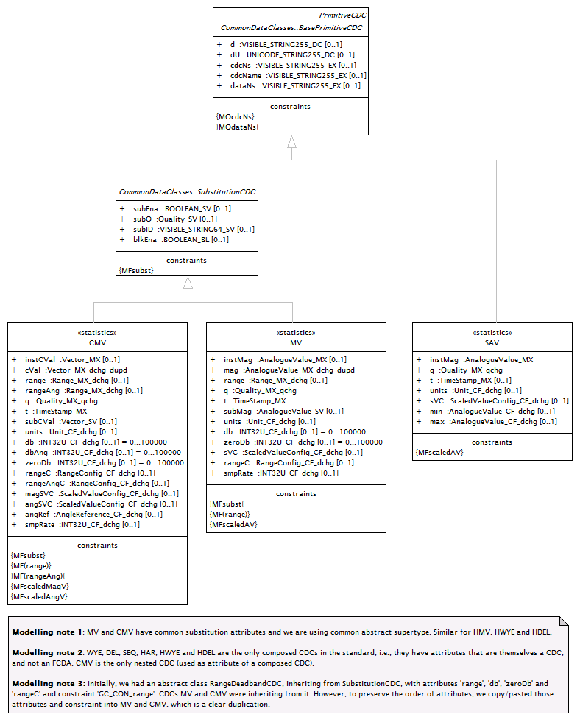

Figure 24: IEC 61850 Measurements
    - Nested DataObjects

Nested IEC 61850 Data Objects shall be exposed using nested IEC 62541 Object Nodes by all servers and also by IEC 62541 Variable Nodes by servers conforming to the Full Profile.
  - IEC 61850 Functional Constraints
IEC 61850 Functional Contstraints are mapped onto IEC 62541 Objects as Instances of “IEC 61850 Functional Contraint” Object Types. All “IEC 61850 Functional Contraint” Objects exposed by a Server shall appear in the IEC 62541 Server Address Space.
Figure 25: Exposing IEC 61850 Functional Constraint Objects in an IEC 62541 Server’s AddressSpace
The following of “IEC 61850 Functional Constraint” Object Data is mapped as an IEC 62541 Attribute.
- Name: The name of an of “IEC 61850 Functional Constraint” Object shall be exposed using the IEC 62541 NodeName Attribute.
- The TypeDefinition shall be set to the well-known Object Type Node ID: “s=IEC61850ReportControlBlock”.
Besides exposing IEC 61850 Functional Constraints, IEC 61850 Servers shall expose Functionally Constrained Data in the following way:
- The IEC 62541 NodeID for IEC 61850 Functional Constrained Data exposed by a Server shall conform to the following format: <LNVariableName>.<FC>.<LNDataObjectName1>.<SubDataObjectName1> (e.g. MMXU1.MX.A.phsA)
- The IEC 62541 NodeID for IEC 61850 Functional Constrained Data Attributes exposed by a Server shall conform to the following format: <LNVariableName>.<FC>.<LNDataName1>.<AttributeName1>.<subDataAttributeName1> (e.g. XBCR1.ST.Pos.origin.orCat)
  - IEC 61850 Data Attributes
As illustrated below, all IEC 61850 Data Attributes with an IEC 61850 ST, MX, CO, SP, BR, RP, LG, MS, and US functional constraint shall be exposed as IEC 62541 DataVariables.
Figure 26: Exposing IEC 61850 FCDA Data Variable Types in an IEC 62541 Server’s AddressSpace

As illustrated below, all IEC 61850 Data Attributes with the exception of an IEC 61850 SV, CF, DC, SG, SE, EX, GO, and GS functional constraint shall be exposed as IEC 62541 Properties.
Figure 27: Exposing IEC 61850 FCDA Property Types in an IEC 62541 Server’s AddressSpace

All IEC 61850 DataAttributes exposed by an IEC 62541 Server shall appear in the IEC 62541 Server Address Space, however exposing VariableTypes is only required for Servers that expose the Full Data Profile.
    - IEC 61850 Data Attribute Mapping
The inheritance of IEC 61850 Packed and Constructed Data Attributes is illustrated below:

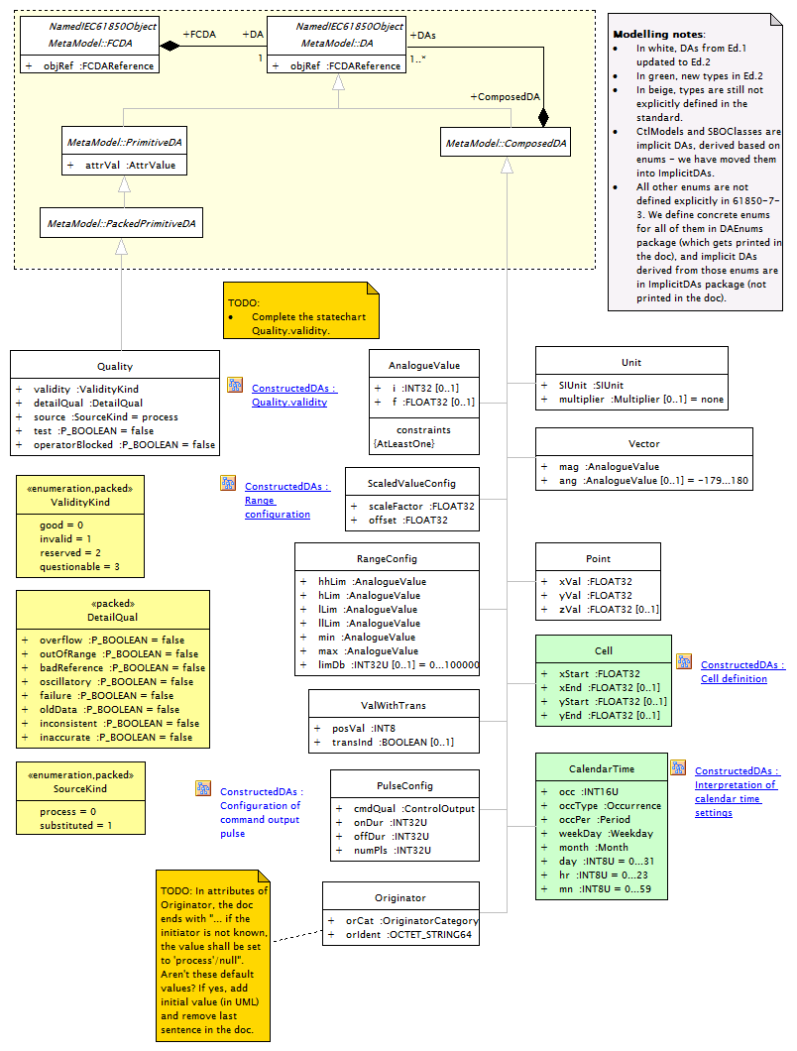
Figure 28: IEC 61850 Constructed Data Attributes

IEC 61850 Packed Constructed Data Attributes shall be exposed by an IEC 62541 Server as a Parent DataVariable that HasComponent Child DataVariables. For example, the IEC 61850 Point Data Attribute shall be exposed as a Point DataVariable which contains xVal, yVal, and zVal child DataVariables. The IEC 62541 Data Type of the Value Attribue of the Point DataVariable is a Complex Type. In this case, the IEC 61850 Point Data Type shall be defined by IEC 61850 Point.xsd. The definition of the Point DataVariable is shown below:

Attribute |  | Value
BrowseName |  | PointType
IsAbstract |  | False
ValueRank |  | −1 (−1 = Scalar)
DataType |  | PointDataType
References | NodeClass |  | BrowseName | DataType | TypeDefinition | Modelling  Rule
Subtype of the BaseDataVariableType
HasComponent | Variable |  | xVal | Float | BaseDataVariableType | Mandatory
HasComponent | Variable |  | yVal | Float | BaseDataVariableType | Mandatory
HasComponent | Variable |  | zVal | Float | BaseDataVariableType | Optional

Figure 29: IEC 61850 Point

ScaledValueConfig
Attribute name | Attribute type | (Value/Value range) Description | M/O/C
scaleFactor | FLOAT32 | Scaling factor for integer representation of analogue value. | M
offset | FLOAT32 | Offset for integer representation of analogue value. | M

Figure 30: IEC 61850 Scaling and Offset
    - IEC 61850 Quality type

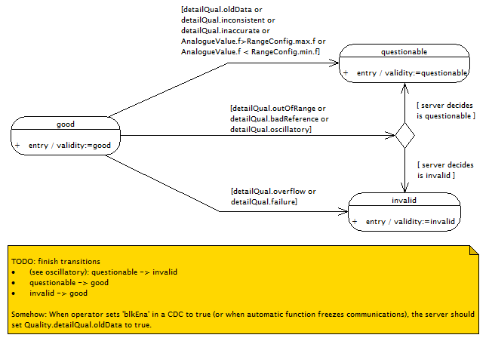
Figure 19: IEC 61850 Quality
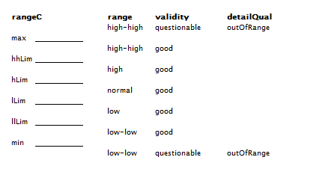
Figure 31: IEC 61850 Quality

Client Severity | OPC Severity
HIGH | 801 – 1 000
MEDIUM HIGH | 601 – 800
MEDIUM | 401 – 600
MEDIUM LOW | 201 – 400
LOW | 1 – 200

Figure 32: IEC 62541 Quality Ranges

    - Specific Data Mapping
- IEC 61850 ObjectName shall be exposed as an IEC 62541 BrowseName.
- IEC 61850 ObjectReference shall be exposed as the NodeId of a Target of an IEC 62541 Object Node Reference
- IEC 61850 PHYCOMADDR shall be exposed as an IEC 62541EndPointAddress
- IEC 61850 PackedList Type shall be exposed as an IEC 62541 Complex Variable
- IEC 61850 Timestamps and Entry Times shall be exposed as an IEC 62541 Timestamps
- IEC 61850 Curves shall be exposed as an IEC 62541 Complex Variable
    - IEC 61850 ServiceError type
    - IEC 61850 TriggerConditions type
    - IEC 61850 ReasonCode (ReasonForInclusion)
    - IEC 61850 Aggregates
  - IEC 61850 Data Types

Name | Value Range | IEC 62541 Data Type
BOOLEAN | 0,1 (false, true) | Boolean
INT8 | I–128 to 127 | Int16
INT16 | –32 768 to 32 767 | Int16
INT24 | -8 388 608 to 8 388 607 | Int32
INT32 | –2 147 483 648 to 2 147 483 647 | Int32
INT64 | –2**63 to (2**63) –1 | Int64
INT8U | Unsigned integer, 0 to 255 | UInt16
INT16U | Unsigned integer, 0 to 65 535 | UInt16
INT24U | Unsigned integer, 0 to 16 777 215 | UInt32
INT32U | Unsigned integer, 0 to 4 294 967 295 | UInt32
FLOAT32 | Range of values and precision as specified by IEEE 754 single-precision floating point | Float
ENUMERATED | Ordered set of values, defined where type is used. Values shall be assigned in the SCSMs. | Enumeration
CODED ENUM | Ordered set of values, defined where type is used. Values shall be assigned in the SCSMs. | Enumeration
OCTET STRING | Max. length shall be defined where type is used | ByteString
VISIBLE STRING | Max. length shall be defined where type is used | String
UNICODE STRING | Unicode coding is defined in the SCSM. Max. length shall be defined where type is used | String
Currency | A currency identification code based on ISO 4217 3-character currency code. The concrete coding shall be defined by the SCSMs. | String

Table 33: IEC 61850 Data Type to IEC 62541 Built-in Data Type Mapping
The diagram below illustrates how a IEC 61850 Primitive Data Types shall appear in a Server’s AddressSpace :
Figure 34: Exposing IEC 61850 ctlModel Enumerations in an IEC 62541 Server’s AddressSpace

Figure 34: Exposing IEC 61850 ctlModel Enumerations in an IEC 62541 Server’s AddressSpace
  - IEC 61850 Hierarchy
The diagram below illustrates the standard hierarchy of IEC 61850 Objects.
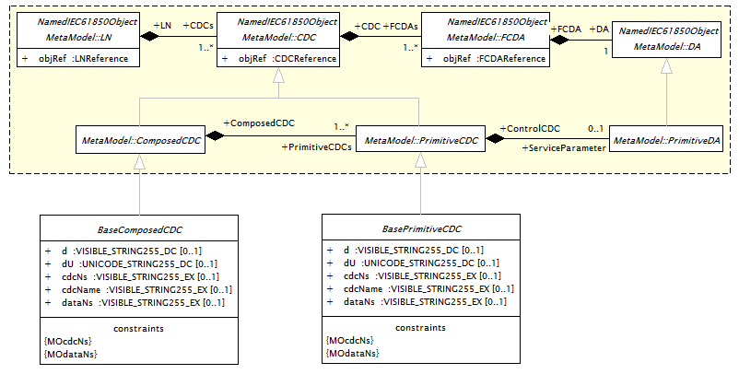
Figure 35: IEC 61850 Hierarchy
The IEC 62541 meta model supports modelling of hierarchies via the use of hierarchical relationship types. To structure the objects three standard UA Reference-Types are used:
- A subtype of the IEC 62541 Contains Reference type shall be used to group an IEC 61850 Server’s components.
- A subtype of the IEC 62541 Contains Reference type shall be used to group a LogicalNode’s components including Data Classes
- A subtype of the IEC 62541 Contains Reference type shall be used for Data Object components include FCs.
- A subtype of the IEC 62541 Contains Reference type shall be used for Data Attributes under FCs.
The diagram below illustrates an example IEC 62541 Address Space used to expose IEC 61850 data. In this example, a Relay_1 Object of IEC 61850 ServeType Contains the IEC 61850 LogicalDevice IED_0001 of IEC 61850 LogicalDevice Object Type. File DownLoad is a Program with input and output Arguments. These Arguments as well as the DataVariables actVal, q, and t are associated with built-in the IEC 62541 DataTypes String, Float, Quality and TimeStamp respectively.
Figure 36: Example IEC 62541 Address Space
- IEC 61850 ACSI Mapping
  - ACSI Service Mapping
    - IEC 61850 Association Multiplicity
There are two types of application associations specified in IEC 61850-7-2. These are:
- two-party associations
- multicast associations
This document does not describe how multicast associations can be supported using IEC 62541.
    - IEC 61850 Association Session Model
As specified by ACSI, IEC 62541 specifies a stateful association session model. IEC 62541 association state information does not persist across application Sessions. Examples of state-information are user credentials and continuation points for operations that span multiple requests.
IEC 62541 Sessions are defined as logical connections between Clients and Servers. Sessions are independent of which transport is used (WebSocket, AMQP, HTTPS, etc.). IEC 62541 Session life cycle is independent of the connection state of the underlying communications protocol. Sessions terminate based on Client or Server request, or based on inactivity of the Client. The inactivity time interval is negotiated during Session establishment.
As specified by ACSI, IEC 62541 application level security relies on a secure communication channel that is active for the duration of the application Session and ensures the integrity of all Messages that are exchanged. This means users need to be authenticated only once, when the application Session is established. The mechanisms for discovering IEC 62541 Servers and establishing secure communication channels and application Sessions are described in IEC 62541 Part 4 Services. Additional information about the Discovery process is described in IEC 62541 Part 12: Discovery. A summary of system wide security is provided in IEC 62541 Part 2 Security Model.
As specified by ACSI, when a Session is established, the Client and Server applications negotiate a secure communications channel and exchange software Certificates that identify the Client and Server and the capabilities that they provide. Authority-generated software Certificates indicate the IEC 62541 Profiles that the applications implement and the IEC 62541 certification level reached for each Profile. The details of each Profile and the Certificates are specified in IEC 62541 Part 7 Profiles. Certificates issued by other organizations may also be exchanged during Session establishment.
The Server further authenticates the user and authorizes subsequent requests to access Objects in the Server. Authorization mechanisms, such as access control lists, are not specified by the IEC 62541 specification. They are application or system-specific.
    - IEC 61850 Solicited services
As with IEC 61850 ACSI, the normal case of an IEC 62541 service is synchronous communication between server and client. This means that the client sends a request to the server and that the server in turn directly responds with either a positive response - in case of successful communication - or a negative response – in case of unsuccessful communication. In the case of successful communication the data is successfully sent. In the case of unsuccessful communication the corresponding service error code is sent.
IEC 62541 synchronous communication is independent of the transport used.
    - IEC 61850 Unsolicited services
IEC 61850 ACSI describes Reporting as unsolicited/spontaneous transmission of values from data objects from a server to clients. IEC 61850 Reporting meets a number of crucial requirements for event-driven information exchange. IEC 61850 Reporting provides mechanisms for transferring data values caused by well-defined conditions. In contrast to high bandwidth and time-consuming fast reading (polling) devices for extraordinary event occurrences, reporting provides immediate transmission of events. However, IEC 61850 ACSI does not specifically say how Reporting shall be accomplished at the network protocol level.
As with IEC 61850 ACSI, with IEC 62541, a client can subscribe for events. These events can be restricted based on client defined filters. In addition, these events can also be used to trigger the reporting of data. The Subscription mechanism of IEC 62541, while not directly unsolicited, can support the requirement for transferring data values caused by well-defined conditions. In all cases subscriptions, whether they are trigger or a normal part of communication with periodic updates, are much more efficient then polling.
  - IEC 61850 Association
    - Associate

IEC 61850 ACSI requires that application associations provide a bi-directional connection-oriented information exchange which is reliable and secure from end to end. IEC 62541 Sessions Services provide this functionality. An IEC 61850 Associate request maps to a sequence of IEC 62541 Service Requests:
- OpenSecureChannel: Open or renew a SecureChannel ensures Confidentiality and Integrity for Message exchange during a Session. A SecureChannel is a long-running logical connection between a single Client and a single Server. This channel maintains a set of keys known only to the Client and Server, which are used to authenticate and encrypt Messages sent across the network. The SecureChannel Services allows the Client and Server to securely negotiate the keys to use.
- CreateSession: CreateSession causes the Server to return two values which uniquely identify the Session. The first value is the SessionId which is used to identify the Session in the audit logs and in the Server’s address space. The second is the AuthenticationToken which is used to associate an incoming request with a Session.
- ActivateSession: Used by the Client to submit its SoftwareCertificates to the Server for validation and to specify the identity of the user associated with the Session.
- CreateSubscrition: When communicating with a Server that supports the Full Profile, the Client may subscribe to “IEC 61850 Report” Notifications using the parameters specified in the UnBuffered Report Control Object Node. When communicating with any Server, the Client may also subscribe to “IEC 61850 Report Available” Notifications using the parameters specified in the Buffered Report Control Block Object Node. The schema for the “IEC 61850 Report” shall match the schema defined by IEC 61850 7-2 ACSI Report. The actual “IEC 61850 Report” Notification send to a Client includes the standard IEC 62541 Notification Fields such as IEC 62541 SequenceNumber and Timestamp. The schema for “IEC 61850 Report Available” is empty. The actual “IEC 61850 Report Available” Notification sent to a Client includes the standard IEC 62541 Notification Fields such as IEC 62541 SequenceNumber and Timestamp.
- CreateMonitoredItems: If a Server supports the Full Profile, it shall expose a single Data Variable named “IEC61850Report” under each IEC 61850 Buffered and Unbuffered Control Block. The content of the Value Attribute of this Data Variable is an XML string whose content is defined by IEC 61850 Report. When communicating with a Server that supports the Full Profile, the Client creates a subscription for each IEC 61850 Report Control Block and then calls CreateMonitoredItems.

    - Abort
IEC 62541 Cancel: Used to cancel outstanding Service requests. Successfully cancelled service requests shall respond with Bad_RequestCancelledByClient.
    - Release
An IEC 61850 Release request maps to a Sequence of IEC 62541 Service Requests:
- DeleteSubscription: This Service is used to terminate Subscriptions that the Client created during the Association process.
- CloseSession: This Service is used to terminate a Session. The Server takes the following actions when it receives a CloseSession request:
  - It stops accepting requests for the Session. All subsequent requests received for the Session are discarded.
  - It returns negative responses with the StatusCode Bad_SessionClosed to all requests that are currently outstanding to provide for the timely return of the CloseSession response. Clients are urged to wait for all outstanding requests to complete before submitting the CloseSession request.
  - It removes the entry for the Client in its SessionDiagnosticsArray Variable.
- CloseSecureChannel: Used to terminate a SecureChannel. The request Messages shall be signed with the appropriate key associated with the current token for the SecureChannel.
    - HeartBeat Messaging
IEC 62541 PublishRequest: This service is used to request the Server to return a NotificationMessage or a KeepAliveMessage. Subscriptions have a KeepAliveCounter that counts the number of consecutive PublishingCycles in which there have been no Notifications to report to the Client. When the maximum KeepAliveCount is reached, a PublishRequest is de-queued and used to return a KeepAliveMessage. This KeepAliveMessage informs the Client that the Subscription is still active. Each KeepAliveMessage is a response to a PublishRequest in which the NotificationMessage parameter does not contain any Notifications and that contains the SequenceNumber of the next NotificationMessage that is to be sent.
  - IEC 61850 Server Services
    - GetServerDirectory
IEC 62541 Browse: An IEC 62541 Server shall expose IEC 61850 LogicalDevice and File Object Nodes as child Nodes of the containing IEC 61850 Server’s Object Node. The IEC 62541 Browse Service supports filtering on the basis of IEC 62541 Reference Type (e.g. HasLD or HasFile).
  - IEC 61850 LogicalDevice Services
    - GetLogicalDeviceDirectory
IEC 62541 Browse: An IEC 62541 Server shall expose IEC 61850 LogicalNode Object Nodes as child Nodes of the containing IEC 61850 LogicalDevice Object Node. The IEC 62541 Browse Service supports filtering on the basis of IEC 62541 Reference Type (e.g. HasLN).
  - IEC 61850 LogicalNode Services
    - GetLogicalNodeDirectory
IEC 62541 Browse: An IEC 62541 Server shall expose IEC 61850 Data Object, DataSet, and Control Block Object Nodes as child Nodes of the containing IEC 61850 LogicalNode Object Node. The IEC 62541 Browse Service supports filtering on the basis of IEC 62541 Reference Type (e.g. HasDO, HasDS, HasCB).
    - GetAllDataValues
IEC 62541 Read: Provides access to values for a single Functional Constraint of one or more to Attributes that are part of one or more Logical Node Object Nodes.
  - IEC 61850 Data Access Services
    - GetDataValues
IEC 62541 Read: Provides access to values of one or more Data Attribute Variable Nodes that are part of one or more Data Object Variable Nodes.
    - SetDataValues
IEC 62541 Write: Used to write values to one or more Data Attribute Variable Nodes of one or more Data Object Variable Nodes.
    - GetDataDirectory
IEC 62541 Browse: An IEC 62541 Server shall expose IEC 61850 Data Object Nodes as child Nodes of the containing IEC 61850 Data Object Object Node.
    - GetDataDefinition
IEC 62541 Browse: An IEC 62541 Server shall expose IEC 61850 Data Attribute Variable Nodes as child Nodes of the containing IEC 61850 Data Object Object Node.
  - IEC 61850 DataSet Services
    - GetDataSetValues
IEC 62541 Read: This Service is used to read values from one or more Data Object or Data Attribute Data Variable Nodes contained by the IEC 61850 DataSet Object Node.
    - SetDataSetValues
IEC 62541 Write: This Service is used to write values to one or more Data Object or Data Attribute Data Variable Nodes contained by the IEC 61850 DataSet Object Node.
    - CreateDataSet
IEC 61850 CreateDataSet: A Client shall issue an IEC 62541 AddNode Service call for the DataSet Object Node as well as its contained FCDA Data Variable Nodes.
    - DeleteDataSet
IEC 61850 DeleteDataSet: A Client shall issue IEC 62541 DeleteNode Service call for all contained FCDA Data Variable Nodes as well as for the DataSet Object Node.
    - GetDataSetDirectory
IEC 62541 Browse: This Service is used to discover the FCDA Data Variable Nodes contained by a DataSet Object Node. The IEC 62541 Browse Service supports filtering on the basis of IEC 62541 Reference Type (e.g. HasFCDA).
  - IEC 61850 Setting Group Control Block Services
    - SelectActiveSG
IEC 62541 Write: This Service is used to write values to Attributes of one SG Object Nodes.
    - SelectEditSG
IEC 62541 Write: This Service is used to write values to Attributes of one SG Object Nodes.
    - SetEditSGValue
IEC 62541 Write: This Service is used to write values to Attributes of one SG Object Nodes.
    - ConfirmEditSGValues
IEC 62541 Write: This Service is used to write values to Attributes of one or more SG Object Nodes.
    - GetEditSGValue
IEC 62541 Read: Provides access to Attributes that are part of one or more SG Object Nodes.
    - GetSGCBValues
IEC 62541 Read: Provides access to Attributes that are part of one or more SGCB Object Nodes.
  - IEC 61850 Report Control Block Services
    - Report
For IEC 61850 Unbuffered Reporting, the IEC 62541 PublishResponse shall contain an “IEC 61850 Report” or a KeepAliveMessage. Client strategies for issuing PublishRequests for unbuffered “IEC 61850 Report” Notifications may vary depending on the networking delays between the Client and the Server. In many cases, the Client may wish to issue a PublishRequest immediately after enabling a Report, and thereafter, immediately after receiving a PublishResponse. Note that because an “IEC 61850 Report” is a complex type, IEC 61850 Unbuffered Reporting is not backward compatible with existing OPC DA Clients and Servers.

For IEC 61850 Buffered Reporting, two Notifications are used: “IEC 61850 Report” and “IEC 61850 Report Available”. The Server shall create an “IEC 61850 Report Available” Notification whenever a new “IEC Report” Notification is created. Client strategies for issuing PublishRequests for “IEC 61850 Report Available” Notifications may vary depending on the networking delays between the Client and the Server.

  - IEC 61850 Log Control Block Services
  - IEC 61850 Control Services
    - Select
IEC 62541 Read: This Services is used to access one or more Attributes of one or more Control Object Nodes.
    - SelectWithValue
IEC 62541 Write: This Service is used to write values to one or more Attributes of one or more Control Object Nodes.
    - Cancel
IEC 62541 Write: This Service is used to write values to one or more Attributes of one or more Control Object Nodes.
    - Operate
IEC 62541 Write: This Service is used to write values to one or more Attributes of one or more Control Object Nodes.
    - CommandTermination
IEC 62541 Servers shall support a CommandTermination EventType subtyped from BaseEventType.
    - TimeActivatedOperate
IEC 62541 Write: This Service is used to write values to one or more Attributes of one or more Control Object Nodes.
  - IEC 61850 File Transfer Services
IEC 62541: Invoke File Transfer Program

See www.opcfoundation.org
IEC 62541 Terms appear in italics
Note that the maximum lifetime is requested by the Client. The Server should attempt to honor the Client request for this parameter, but may negotiate this value up or down to meet its own constraints. See Section IEC 62541 Part 4: Services for more information.
If the Server detects that a Client has failed, the Server shall set the IEC 61850 ReportEnable flag to false. For more information, see discussion of IEC 61850 SetBRCBValues below.
Object Automation Reference
COM (Common Object Model) and DCOM (Distributed Common Object Model) are Microsoft technologies for inter-process communication on the Windows platform.
While OPC DA COM Versions 1 and 2 have no support, OPC DA Version 3 has limited support for complex data types. This support is not as rich as IEC 62541 or 8-1. For example, with OPC DA Browse OPC DA COM clients can see the hierarchy of complex data, there are no OPC DA COM V2/V1 function calls that explicitly access complex data where a single instance of quality and time can be retrieved for multiple “item” values or perform structured access in an “atomic” fashion.
Courtesy of SISCO.
The topic of transactions and complex data are overlapping. For example, while IEC 61850-1 does not support transactions as they are typically defined, transaction functionality can be achieved via the use of reading and writing complex data. For example, IEC 61850-8-1 clients and servers can support atomic reading and writing of complex objects and this is a formal requirement for executing ACSI control actions including the “operate”, “select-with-value”, and “cancel” services using the 8-1 mapping. While there is no formalized standard for how to use OPC DA COM to execute “transactions”, there are multiple IEC 61850 products on the market that implement mechanisms to provide atomic writing of complex objects Using OPC DA COM which is used primarily for the above referenced ACSI control services. This document provides a simple extension to how OPC DA COM is used to today and thereby eases migration existing applications from OPC DA COM to IEC 62541.
Alarming is currently being considered by an IEC TC 57 WG 10 Task Force. This task force may extend the ACSI data model and add a standard alarming state transition model for IEC 61850 servers. Note that it is likely that neither IEC 62541 nor IEC 61850 8-1 services need to be changed to support Alarming.
IEC 62541 Event filtering corresponds to IEC 61850 TrgOps. For more information see discussion of IEC Report Control Block above.
One could suggest that this technique is preferred versus something like using a TCP_KEEPALIVE. TCP_KEEPALIVE is not at the application layer so if the TCP stack is a separate process from the IEC 61850 application, the use of TCP_KEEPALIVE may not yield an appropriate indication that the IEC 61850 application is still executing. For example, when using an XMPP relay, a TCP_KEEPALIVE only indicates the health of the point to point connection between either endpoint and the relay. However, the TCP_KEEPALIVE cannot inform either endpoint about the health of each other.

